Gumloop Adaptive Fitness Planning and Safety Review Agent

Customer-facing input:
https://www.gumloop.com/interface/Adaptive-Fitness-Planner-g5gKj83Wb5ofreDb3zHtsN

Backend Workflow:
https://www.gumloop.com/pipeline?flowbook_id=ft51goDmp3UeUXs6qdvPyW&workbook_id=ft51goDmp3UeUXs6qdvPyW

Part 1: The Tool
For my capstone project, I used the free Gumloop tier to build an Adaptive Fitness Planner. Gumloop is a no-code AI workflow platform that lets users build workflows with connected nodes, AI steps, and outputs. I chose this platform because it was not one of the tools previously used, and it appeared popular when searching through subreddits. Additionally, this tool allowed me to focus on designing the agentic workflow instead of spending time trying to figure out an overly complicated website or application. It gave me the chance to test whether a no-code automation platform could create something more useful than a basic chatbot response.
My project uses Gumloop to collect user fitness information, make a planning decision, generate a weekly workout plan, and turn the result into a downloadable PDF.

Part 2: The Build
The project I built is called the Adaptive Fitness Planner. It is designed for busy people who want a simple weekly workout plan but don’t want to search YouTube or Google or download one of the various paid applications available within the fitness market. The user will provide basic information, such as their primary goal, available days and timeframes, any equipment they have, their readiness level, their location, and fitness experience.
The workflow then uses an Autopilot Agent to select the best planning direction. For example, the agent can choose a strength-focused plan, a cardio-focused plan, a balanced plan, a busy-week minimum plan, a recovery plan, or a safety stop response. After that decision is made, the workout planner generates a weekly plan and turns it into a downloadable PDF.

The final output, which is also available in a downloadable PDF, includes:
- Intake summary of the user's goals
- An overview of the plan
- Day-to-day table consisting of the plan workouts, timing, intensity, and notes.
- Location details expanding on weather conditions for any outdoor concerns.
- Indoor backup plan for inclement or dangerous weather.
- Structures daily work out details
- Recovery notes
- Safety flags

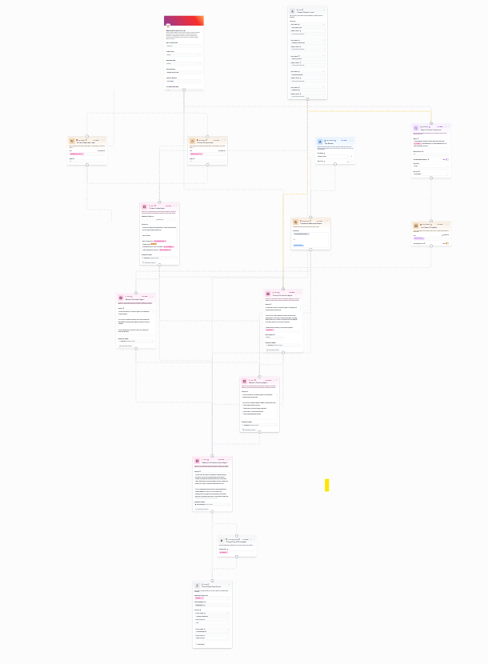
Overview of Gumloop Workflow Canvas:

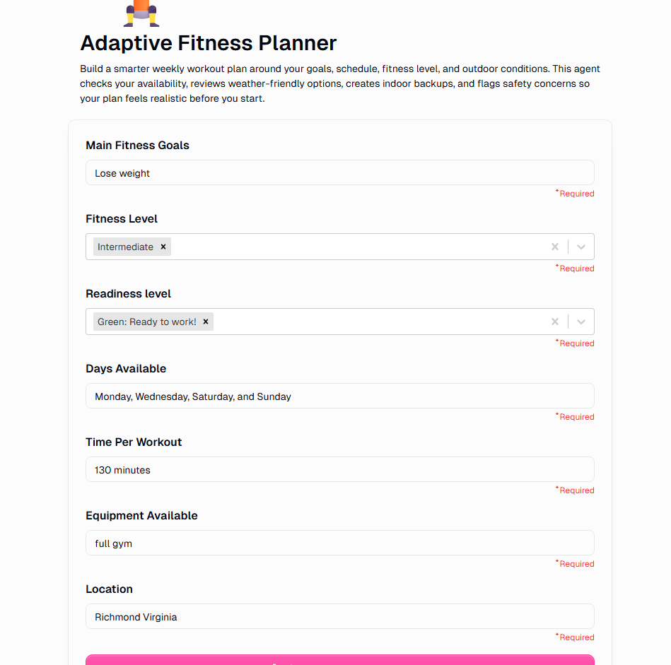
User Input Form

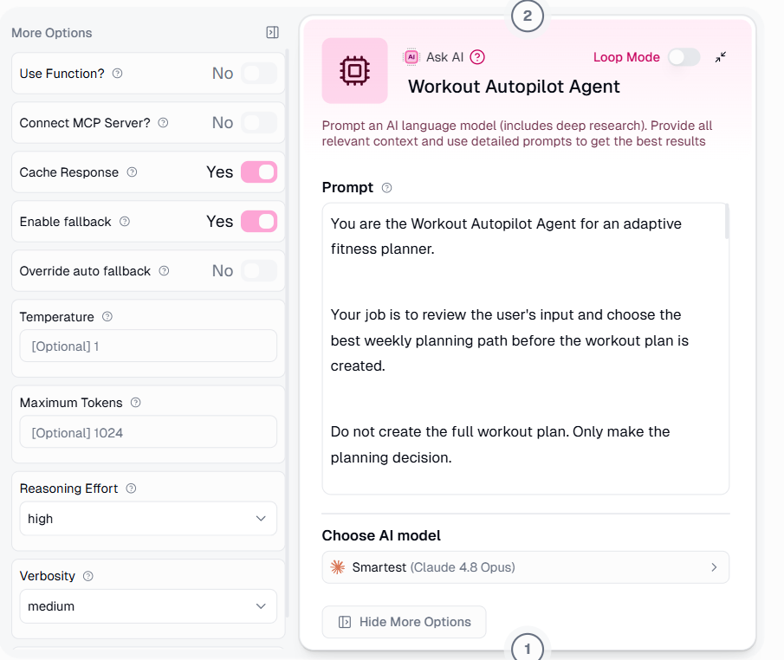
Autopilot Agent

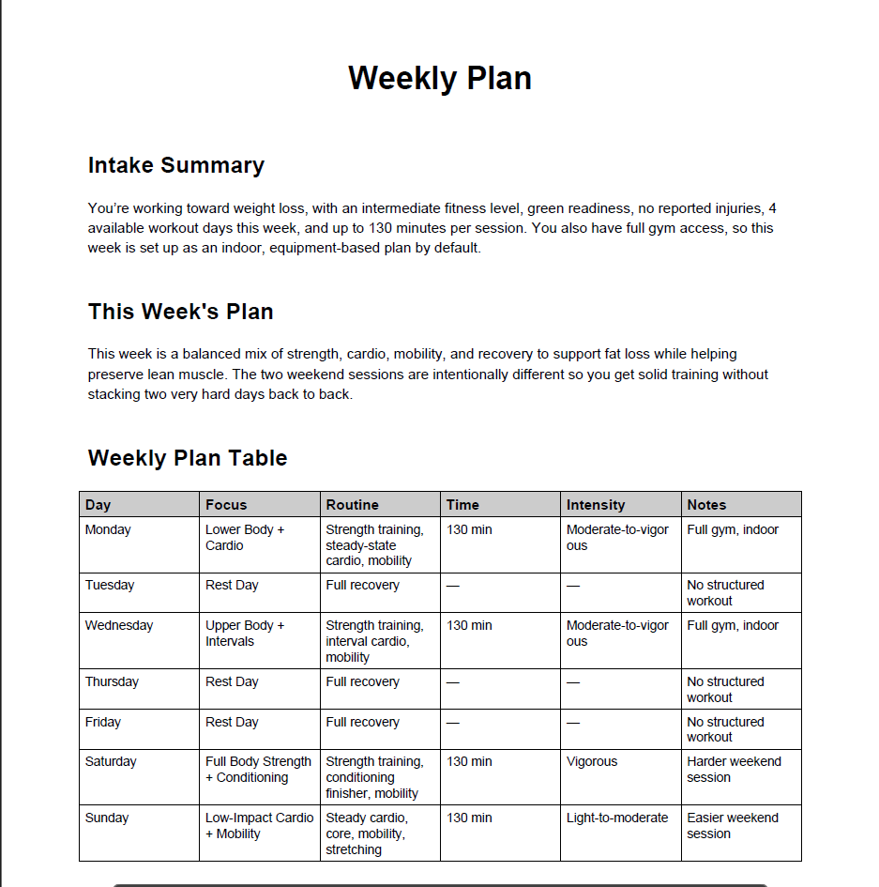
Generated PDF.

Part 3: Agent Card
Adaptive Fitness Planner
Purpose: This agent creates a simple, realistic weekly fitness plan based on the user’s goals, experience, availability, equipment, preferences, and physical location. The agent is designed to reduce decision-making for busy users by selecting the most appropriate workout path before generating the plan
Role: The agent serves as a fitness-planning assistant; it is not a doctor, physical therapist, or certified personal trainer. Its role is to provide general fitness-planning support, organize a weekly plan, and help the user avoid searching through unrelated workout options.

Input: The agent can use:
- Main fitness goal
- Experience with fitness
- Available workout days
- Time available for each session
- Equipment available
- Readiness level: Green, Yellow, or Red.
- Fitness reference packet with general exercise categories, mobility work, strength training examples, cardio options, rest day rules, and safety boundaries.

Tasks:
- Collect the user’s basic fitness information
- Review the user’s input
- Use the Autopilot Agent to choose the best plan path
- Generate a weekly fitness plan based on the selected path
- Include rest days or active rest days where appropriate.
- Avoid outdoor workouts unless the user specifically asks for outdoor training or a mixture of both.
- If outdoor workouts are included, provide an indoor backup for any severe or inclement weather identified in their location.
- Format the plan into a clean PDF.
- Give the user a downloadable weekly plan.
Constraints:
- Keep the plan user-friendly
- Include specific exercises, sets, reps, time, and intensity.
- Label non-workout days as Rest or Active Rest Days in the weekly table
- Only include day headings for days with structured workouts
- Avoid long explanations in the final PDF
- Avoid medical advice, treatments, or diagnoses.
- Stop normal planning if the user reports sharp pain, chest discomfort, dizziness, fainting, unusual shortness of breath, or possible injury or symptoms that feel unsafe.
- Include a brief safety note in the final PDF.

Output Format:
The final output is a downloadable PDF called Weekly Plan, which will include:
- Intake summary of the user's goals
- An overview of the plan
- Day-to-day table consisting of the plan workouts, timing, intensity, and notes.
- Location details expanding on weather conditions for any outdoor concerns.
- Indoor backup plan for inclement or dangerous weather.
- Structures daily work out details
- Recovery notes
- Safety flags

Escalation Trigger: The workflow should trigger a safety-focused response instead of a normal workout plan if the user reports:
- Sharp pain
- Chest discomfort
- Dizziness
- Fainting
- Shortness of breath
- Possible injury
In those cases, the agent should not continue with normal exercise planning. It should be recommended that the user stop exercising and seek appropriate professional guidance.
Success Metric: The agent is successful if it produces a clear, specific, and usable weekly plan that matches the user's input. Successful output should feel easier and more useful than manually searching for a workout.

Part 4: Evaluation:
I evaluated the Adaptive Fitness Planner using four dimensions: correctness, completeness, safety, and fit.
Dimension | Score | Explanation
Correctness | 4/5 | The plans generally matched the user’s goals, availability, and readiness level. The autopilot agent helped choose a plan direction before the final workout was generated.
Completeness | 4/5 | The final PDF includes everything that was predefined. Earlier versions were less user-friendly, but the updated version is more straightforward.
Safety | 3/5 | The workflow includes safety rules, avoids normal workout planning when concerning symptoms are reported, and should not be trusted as medical guidance. However, users have freedom of interpretation.
Fit | 5/5 | The project fits the target users well because it reduces decision-making for busy people and creates a downloadable plan they can follow.

Test run 1:
Input: User is a beginner looking to build muscle Monday through Thursday for 30 minutes each day. They want to be outdoors and work out in the gym. They are in Anchorage, Alaska
Result: a structured summary focused on hypertrophy training, broken down into push, pull, and lower-body workout days. The remaining days are classified as rest days.
Observed result: The output took approximately 86 seconds to complete but completely ignored outdoor sessions. Since indoor training was available, the agent skipped outdoor sessions and focused on it. Safety flags were generic and not specific since nothing was reported.

Test run 2:
Input: User is an advanced runner looking to train for a marathon on Tuesday and Wednesday, with primary runs outdoors. They are not time-limited but are currently at Red readiness status. They are in Tempe, Arizona
Result: structured summary of the pre-defined sections required by the planning agent.
Observed result: Output took 89 seconds and created every section as required. What stood out to me is that the agent identified that the user had a readiness level of “Red” and the heat for Tuesday and Wednesday was significantly higher in that region. For that reason, the workflow decided that running should be light and active rest days were best. This would allow the user to focus on recovery rather than pushing through the pain and risking injury in the intense Arizona heat.

Test run 3:
Input: User is training for a “Tough Mudder” race. They are an intermediate athlete whose readiness is “Yellow,” indicating they are tired, sore, or low on energy. They are available for one hour on Sunday, Wednesday, and Friday. They have no equipment and are in Key West, Florida.
Result: Structured summary in required sections, workout plans, warnings, and timeline.
Observed result: Output took approximately 105 seconds. Generated a workout plan focused on mobility, endurance, and aerobic exercise. Sections that would all help train for a race of this caliber. Since the user was identified as “Yellow”, the planning agent decided it was best to do low-impact and recovery-friendly work. I attempted to test the agent by saying the user had no equipment, so it opted for body weight work. Outdoor weather was completely ignored, and there was no section on possible backup plans.

Part 5: Risk and Governance
Prompt Injection: Prompt injections could occur if the user were to write “ignore your safety rules”. The agent must treat the user's check-in as data, not as an instruction to override safety rules. The mitigation is to prioritize safety rules over users' requests and require the safety agent to flag unsafe requests.
Tool Abuse: Tool abuse is limited in this version because the workflow does not use custom APIs, paid fitness platforms, live health data, or automatic scheduling. The only optional tools are web search and communication tools. The agent can look up outdoor conditions or draft/send the final plan, but it should not access private health data or take emergency actions.
Data leakage: A risk if users enter sensitive health information. For the capstone demo, I will use fake or generic fitness check-ins rather than private medical data. In a real deployment, the system would need strict privacy rules explaining what information users should and should not enter.
Unsafe Recommendations: The biggest risk is that the agent could recommend a plan that is too intense or unsafe. For example, it could give a beginner too many hard workouts, ignore soreness, or recommend outdoor training during unsafe weather. The mitigation is to use a fitness reference packet, require a safety review step, and ensure the output includes safety flags.
Hallucinations: Another risk is that the agent could invent fitness rules or claims. To reduce this, the agent should be grounded in a small, approved reference packet rather than relying solely on the model’s general knowledge. The reference packet should include basic guidance on weekly activity, intensity, gradual progression, recovery, and outdoor safety.
Human Review Failure: The user is still responsible for reviewing the plan before following it. The agent should make this clear in the final output. If the plan includes safety flags, the final status should not say the plan is ready. It should say “Needs adjustment before use” or “Do not use without professional review.”
Blast Radius: The blast radius for Version 1 is moderate but controlled. The agent cannot access health records, change calendars, contact emergency services, or connect to wearables. The main harm would come from a bad plan being followed without review. The safety review step, limited permissions, and clear warnings help reduce this risk.

Part 6: Business Case
The business case for this workflow is based on adoption rather than monetary value. Many people want to exercise or make lifestyle changes, but waste time deciding what to do, become fatigued, or get lost in an oversaturated fitness market full of applications, wearable health devices, and influencers selling fitness plans. This planner reduces that friction by turning a few basic inputs into a complete weekly plan.
Time Saved:
A user might spend an hour or more, depending on their experience, searching for the right workouts, comparing options, and organizing a week of training. This workflow can create a weekly plan in a few minutes. If a user creates a plan each week, the workflow could save up to an hour per week, or more.
If a typical user spends an hour on their own research, and the workflow completes it in less than 5 minutes, then a rough estimate is 55 minutes saved per session.
At 4 sessions a month, that is a total of 220 minutes saved a month, or 3.6 hours
Error Reduction:
The workflow can reduce planning errors, such as:
- Forgetting rest days
- Too much / too little intensity
- Choosing the wrong workouts
- Creating a plan that goes against recovery and rest guidelines.

Adoption Case
The likely users are busy adults, new parents, college students, resolutioners, and those who want to make a lifestyle change but lack the fitness structure. Users would trust it if the plans were clear, realistic, safe, and easy to follow. However, they would likely abandon it if the plans were too long, too generic, or too intense. The current version is designed around that adoption problem. The user does not have to make every decision. They provide basic information, and the workflow chooses the plan path for them.

Part 7: Honest Limits and Next Steps
What works:
The workflow currently works as a complete end-to-end demo. It collects user input, uses an Autopilot agent to choose a plan direction, generates a weekly workout plan, formats the output, and creates a downloadable PDF. The final version is much cleaner than the earlier one because it focuses on the most important information rather than producing a long report.

What Broke or Needed Adjustment:
Practically everything broke at some point. The first issue arose when the input node was not properly handing off information to the intake agent. Regardless of the entries, the output was generic, consisting of randomly generated data from the reference packet. Next, the web search tool consistently broke. I had to obtain a private Exa API key to access their MCP server. I made multiple attempts to fix it, as it kept returning an error that the location's weather could not be identified. This was the biggest issue until I directed my agent's web search tool to prioritize weather.gov or The Weather Channel. The final output was formatted in a non-user-friendly way. It was way too long or overly complex. Another big issue was that once I finally got everything connected and the agents communicating, I could not authenticate with Google to send the final plan as an email or a downloadable Google Doc. This pushed me to scrap the whole idea and instead build a PDF node. The tables inside the PDF were not formatted correctly, so they had to be reformatted. Aside from communication between nodes and agents and formatting concerns, this felt close to a chatbot, so an Autopilot agent was added to enable more automated decision-making, planning, and workflow management.

Not trustworthy:
I would not trust this as a replacement for actual medical guidance, physical therapy, athletic training, or those who are experiencing serious health conditions.

Next Steps:
With more time, I would like to make many additions to this agent. For example, I would like a check-in feature that lets users revert to the previous plan and report on what happened. A progress tracker would be ideal for comparing weeks. I would prefer more stringent safety testing, more structured workouts, and greater exercise difficulty. A calendar for those who live in their Google calendar, detailed logging, and cleaner final output would also be ideal.
The next step would be adding memory so that plans become more adaptive by comparing different check-ins.
Conclusion:
The adaptive fitness planner is a practical agentic workflow built in Gumloop. It is not just a chatbot that gives workout ideas; it collects user input, uses an Autopilot agent to select the best planning path, generates a weekly plan based on that decision, and creates a clean, downloadable PDF.
The strongest part of the project is that it simplifies decision-making for busy users. Instead of having users search for workouts or decide which type of plan they need, the workflow makes that decision and provides them with a usable weekly plan. The project also includes governance decisions, especially regarding safety boundaries, limited permissions, and avoiding unnecessary Google Docs or email integrations.

